**

**STIA 1123 PROGRAMMING 2**

MY PROJECT: Pet Registration System

Name: Lim Clarin

Matric no: 263087

Group: F

Lecture: Dr Ahmad Hanis Bin Mohd Shabli

*Login System Coding*

package my.project;

import java.awt.event.ActionEvent;

import java.awt.event.ActionListener;

import javax.swing.JButton;

import javax.swing.JFrame;

import javax.swing.JLabel;

import javax.swing.JOptionPane;

import javax.swing.JTextField;

/**

*

* @author User

*/

public class MyProject {

/**

* @param args the command line arguments

*/

public static void main(String[] args) {

// TODO code application logic here

JFrame frame =new JFrame("Pet Registration System");

JLabel jlbtittle =new JLabel("Login Sistem");

jlbtittle.setBounds(10,0,100,20);

JLabel Jlb =new JLabel ("Name");

Jlb.setBounds(40,40,150,20);

JLabel Jlb2=new JLabel(" Password");

Jlb2.setBounds(40,80,180,20);

JTextField Jtf1 =new JTextField ();

Jtf1.setBounds(120,40,200,20);

JTextField Jtf2=new JTextField();

Jtf2.setBounds(120,80,200,20);

JButton btn1=new JButton("Login");

btn1.setBounds(120,120,90,20);

JButton btn2=new JButton("Cancel");

btn2.setBounds(220,120,80,20);

frame.add(Jtf1);

frame.add(Jtf2);

frame.add(Jlb);

frame.add(Jlb2);

frame.add (jlbtittle);

frame.add(btn1);

frame.add(btn2);

frame.setSize(400,200);

frame.setLayout(null);

frame.setVisible(true);

frame.setResizable(false);

frame.setLocationRelativeTo(null);

frame.setVisible(true);

frame.setDefaultCloseOperation(JFrame.EXIT_ON_CLOSE);

btn1.addActionListener(new ActionListener() {

@Override

public void actionPerformed(ActionEvent e) {

String name = Jtf1.getText();

String pass = Jtf2.getText();

if (name.equals("Clarin") && (pass.equals("12345"))){

JOptionPane.showMessageDialog(null, "Welcome to the System");

frame.setVisible(false);

new MainInterface();

}else{

JOptionPane.showMessageDialog(null, "Login Failed");

}

}

});

btn2.addActionListener(new ActionListener(){

@Override

public void actionPerformed(ActionEvent e){

frame.setVisible(false);

frame.dispose();

}

});

}

}

***UML Diagram***

|  |
| --- |
| Pet |
| -ID : String  -Type: String  -Name: String |
| Pet (ID:String, Type:String, Name:String)  + setID(ID:String) : void  + setType(Type:String) :void  + setName(Name:String): void  + getID():String  + getType():String  + getName():String |

***Pet Class***

package my.project;

/**

*

* @author User

*/

public class Pet {

private String ID,Type,Name;

Pet(String ID,String type,String name){

this.ID=ID;

this.Type=type;

this.Name=name;

}

void setID(String ID){

this.ID= ID;

}

void setType(String type){

this.Type=type;

}

void setName(String name){

this.Name=name;

}

String getID(){

return ID;

}

String getType(){

return Type;

}

String getName(){

return Name;

}

}

***MainInterface***

package my.project;

import java.awt.event.ActionEvent;

import java.awt.event.ActionListener;

import java.io.File;

import java.io.FileWriter;

import java.io.PrintWriter;

import java.util.ArrayList;

import java.util.Scanner;

import javax.swing.JButton;

import javax.swing.JFrame;

import javax.swing.JLabel;

import javax.swing.JOptionPane;

import javax.swing.JScrollPane;

import javax.swing.JTable;

import javax.swing.JTextField;

import javax.swing.table.DefaultTableModel;

/**

*

* @author User

*/

public class MainInterface {

public static ArrayList<Pet> pet = new <Pet>ArrayList();

public static File outFile = new File("Clarin.txt");

public static String[] columnNames = { " No.","ID", "Type", "Name" };

public static DefaultTableModel tablemodel =new DefaultTableModel(columnNames,0);

private static void insertFile(){

try{

FileWriter outFileStream =new FileWriter(outFile); // STORE INTO FILE

PrintWriter outStream = new PrintWriter(outFileStream);

for(int i =0;i<pet.size();i++){

outStream.print (Integer.toString(i+1)+",");

outStream.print(pet.get(i).getID()+",");

outStream.print(pet.get(i).getType()+",");

outStream.println(pet.get(i).getName());

}

outStream.close();

}

catch(Exception e){

JOptionPane.showMessageDialog(null,"Error in insertFile");

}

}

public static void loadFile(){

try{

Scanner scanner =new Scanner (outFile);

String data;

int i =1;

while(scanner.hasNextLine()){

data=scanner.nextLine();

String dataArr[]=data.split(",");

dataArr[0] = Integer.toString(i);

pet.add(new Pet(dataArr[1],dataArr[2],dataArr[3])); //add the id, type,name back to arraylist.

tablemodel.addRow(dataArr);

i++;

}

scanner.close();

}catch(Exception ex){

JOptionPane.showMessageDialog(null,"empty file");

}

}

public static void showFoundItem(int i){

JOptionPane.showMessageDialog(null,"Search item found!\nID: "+pet.get(i).getID() +"\nType:"+pet.get(i).getType() +"\nName:"+ pet.get(i).getName());

}

public static void replaceData(){ //delete old data and replace with a new data

try{

outFile.delete();

outFile.createNewFile();

FileWriter fileOutStream = new FileWriter(outFile);

PrintWriter outStream= new PrintWriter(fileOutStream); //store the data into a file

for (int i=0;i<pet.size();i++){

outStream.print(Integer.toString(i+1)+",");

outStream.print(pet.get(i).getID()+",");

outStream.print(pet.get(i).getType()+",");

outStream.println(pet.get(i).getName());

}

outStream.close();

Scanner scanner = new Scanner (outFile);

String data;

int i =1; // to assign row number

while(scanner.hasNextLine()){

data = scanner.nextLine(); // scan the first row

String dataArr[]=data.split(","); // e.g （hi, hihi)

dataArr[0] = Integer.toString(i);

tablemodel.addRow(dataArr);// put the data into the table

i++;

}

scanner.close();

}

catch(Exception ex)

{

JOptionPane.showMessageDialog(null,"empty file");

}

}

public MainInterface() {

JFrame frame = new JFrame("Pet Registration System");

JLabel jlbtittle =new JLabel("MainInterface");

jlbtittle.setBounds(10,0,100,20);

JLabel Jlb =new JLabel ("Pet's id");

Jlb.setBounds(40,40,180,20);

JLabel Jlb2=new JLabel("Type of Pet");

Jlb2.setBounds(40,80,180,20);

JLabel Jlb3 = new JLabel("Name of Pet");

Jlb3.setBounds(40,120,180,20);

JTextField Jtf1 =new JTextField ();

Jtf1.setBounds(120,40,100,20);

JTextField Jtf2=new JTextField();

Jtf2.setBounds(120,80,200,20);

JTextField Jtf3=new JTextField();

Jtf3.setBounds(120,120,200,20);

JButton btn1=new JButton("Insert");

btn1.setBounds(40,150,80,20);

JButton btn2=new JButton("Delete");

btn2.setBounds(120,150,80,20);

JButton btn3=new JButton("Search");

btn3.setBounds(200,150,80,20);

JButton btn4=new JButton("Update");

btn4.setBounds(280,150,80,20);

JTable jt=new JTable(tablemodel);

JScrollPane jsptable =new JScrollPane(jt);

jsptable.setBounds(40,200,300,200);

jsptable.setVisible(true);

frame.add(Jtf1);

frame.add(Jtf2);

frame.add(Jtf3);

frame.add(Jlb);

frame.add(Jlb2);

frame.add(Jlb3);

frame.add (jlbtittle);

frame.add(btn1);

frame.add(btn2);

frame.add(btn3);

frame.add(btn4);

frame.add(jsptable);

frame.setSize(400,500);

frame.setLayout(null);

frame.setVisible(true);

frame.setResizable(false);

frame.setLocationRelativeTo(null);

frame.setVisible(true);

frame.setDefaultCloseOperation(JFrame.EXIT_ON_CLOSE);

loadFile();

btn1.addActionListener(new ActionListener() { //add button

@Override

public void actionPerformed(ActionEvent e) {

String ID = Jtf1.getText(); // id

String Type = Jtf2.getText(); //type

String Name =Jtf3.getText(); //name

pet.add(new Pet(ID,Type,Name));

insertFile(); //save to file.txt

for(int i=pet.size()-1;i<pet.size();i++){ // display input in table

String[] data =new String [4];

data[0]=String.valueOf(i+1);

data[1]=pet.get(i).getID();

data[2]=pet.get(i).getType();

data[3]=pet.get(i).getName();

tablemodel.addRow(data); // display in row

}

}

});

btn2.addActionListener(new ActionListener (){ //delete button

@Override

public void actionPerformed(ActionEvent e){

String ID =Jtf1.getText();

boolean delete =false; //to run joptionpane if not item found in for loop

for(int i=0;i<pet.size();i++){

if(ID.equals(pet.get(i).getID())){

pet.remove(pet.get(i)); //delete the object

tablemodel.getDataVector().removeAllElements();

//remove all rows in jtable

replaceData(); //delete ,create display in table

delete=true;

}

}

if(pet.isEmpty()){ // if array is empty

tablemodel.fireTableDataChanged(); //reset the table

}else if(delete == false){

JOptionPane.showMessageDialog(null,"Can't find the data");

}

}

});

btn3.addActionListener(new ActionListener (){

@Override

public void actionPerformed(ActionEvent e) { //search button

String ID =Jtf1.getText();

boolean search = false;

for(int i=0;i<pet.size(); i++){

if(ID.equals(pet.get(i).getID())){

showFoundItem(i);

search=true;

}

}

if(search==false){

JOptionPane.showMessageDialog(null,"Cannot find this item!");

}

}

});

btn4.addActionListener(new ActionListener(){

@Override

public void actionPerformed(ActionEvent e){

String ID,Type,Name;

ID=Jtf1.getText();

boolean update= false;

for(int i=0;i<pet.size();i++){

if(ID.equals(pet.get(i).getID())){

Type=Jtf2.getText();

Name=Jtf3.getText();

pet.get(i).setType(Type); //set a new data

pet.get(i).setName(Name); //set a new data(setter method)

tablemodel.getDataVector().removeAllElements(); //remove all data in table

replaceData();

update=true;

}

}

if(pet.isEmpty()){

JOptionPane.showMessageDialog(null,"No data found");

}

else if(update == false)

JOptionPane.showMessageDialog(null,"Item Not Found");

}

});

}

}

***Output***

**Login System**

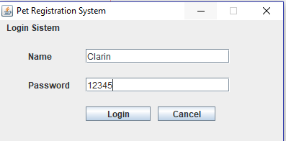

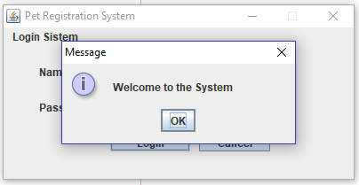

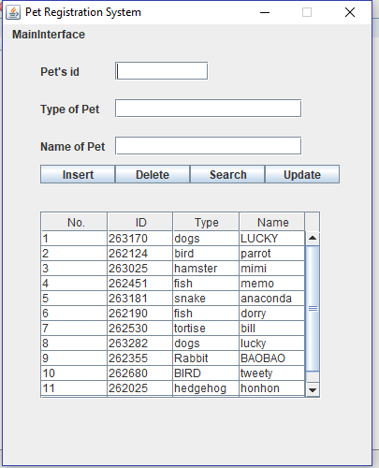***MainInterface***

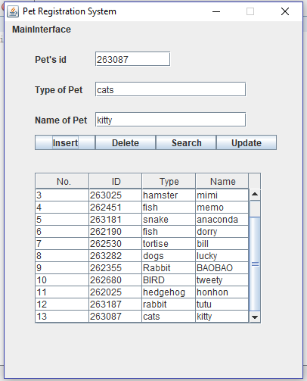***Delete button***

**Insert button**

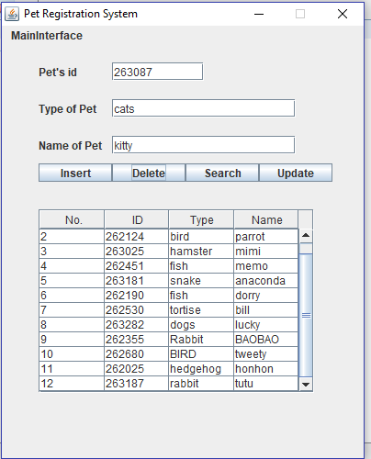

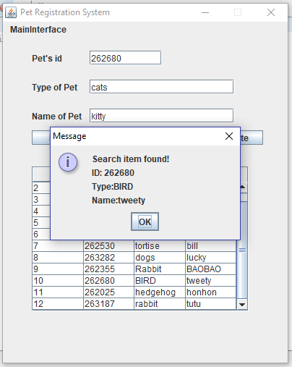***Search button***

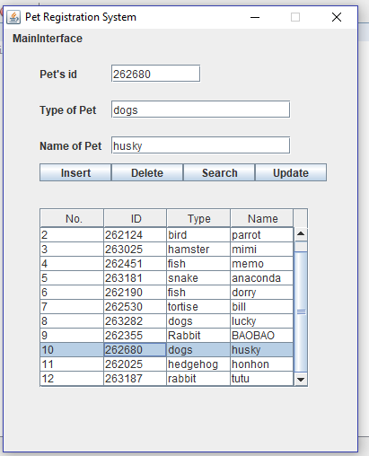***Update button***

***FILE Clarin .txt***

